Sprint 1 - Endurance Design Document

November 8, 2019
Table of Contents
1. Executive Summary 3
1.1 Project Overview 3
1.2 Purpose and Scope of this Specification 3
2. Product/Service Description 3
2.1 Product Context 3
2.2 User Characteristics 3
2.3 Assumptions 3
2.4 Constraints 3
2.5 Dependencies 4
3. Requirements 4
3.1 Functional Requirements 5
3.2 Security 5
3.2.1 Protection 5
3.2.2 Authorization and Authentication 6
3.3 Portability 6
4. Requirements Confirmation/Stakeholder sign-off 6
5. System Design 6
5.1 Algorithm 6
5.2 System Flow 6
5.3 Software 6
5.4 Hardware 6
5.5 Test Plan 7
5.6 Task List/Gantt Chart 7
5.7 Staffing Plan 7

Executive Summary

Project Overview
This project is a test for three developers to see all the steps in coding and developing a new program. The intended audience for this project is students and staff of Monmouth University.

Purpose and Scope of this Specification
The purpose of this specification for its intended audience is to see the limits of how far this robot can be pushed.
In scope
This document addresses requirements related to phase 1 of Project Robot:
- modification of speech to meet legislative mandate ENDUR_02 and ENDUR_4.
- modification of light processing to meet legislative mandate ENDUR_1 and ENDUR_3.
Out of Scope
The following items in phase 2 of Project Robot are out of scope:
- modification of speed to meet legislative mandate ENDUR_6.

Product/Service Description
Some factors that could affect this product could include a water spill, a crack in the ground, bumps. The project also needs the Sphero Edu app to run.

Product Context
This product relates to other products independently. It interfaces with a variety of different smart phones. The product interfaces with phones created by Samsung and Apple.

User Characteristics
- Student-low level experience/low-level technical expertise
- Faculty- mid level experience/mid-level technical expertise
- Staff-high level experience/maximum level technical expertise
- Other-no experience/no technical expertise

Assumptions
As long as a person has a phone and can press the start button, they can run the program if given the code. No prior experience or technical expertise is required because the program can run on its own.

Constraints
- Robot can only be controlled from a certain distance
- Only block code can be used
- Only phones can control the robot

Dependencies
- This new product will require the Sphero Edu app to be downloaded
- Bluetooth will be needed
- A stable Wi-Fi connection will be needed

Requirements

Functional Requirements
Req# | Requirement | Comments | Priority | Date Rvwd | SME Reviewed / Approved
ENDUR_01 | Robot lights up green at start | Also needs to speak | 1 | 11/8 | Bryn
ENDUR_02 | Robot speaks at start | “ready set go” | 1 | 11/8 | Bryn
ENDUR_03 | Robot lights up red on completion | Also needs to speak | 1 | 11/8 | Bryn
ENDUR_04 | Robot speaks on completion | “I’m done and I need water” | 1 | 11/8 | Bryn
ENDUR_05 | Robot makes it around the course | All 4 corners are hit, and it returns to the start | 1 | 11/8 | Bryn
ENDUR_06 | Robot has good timing | Make the robot complete the course faster | 3 | 11/8 | Bryn
ENDUR_07 | Robot will get around bumps | Change block code to fit the course | 2 | 11/8 | Bryn

Security

Protection
- Finger encryption
- Facial recognition
- Pattern lock
- Number lock

Authorization and Authentication
No authorization was required because all activities were handled in person.

Portability
If portability is a requirement, specify attributes of the system that relate to the ease of porting the system to other host machines and/or operating systems. For example,
- Percentage of components with host-dependent code: 50%
- Percentage of code that is host dependent: 100%
- proven portable language: none
- compiler or language subset: block code
- operating system: ios/android
- environment-independence: full independence

Requirements Confirmation/Stakeholder sign-off

Meeting Date | Attendees (name and role) | Comments
11/04/21 | Bryn, Taye, Adnan | confirmed all except ENDUR_05 and ENDUR_06
11/08/21 | Bryn, Taye, Adnan | Confirmed ENDUR_05 and ENDUR_06

System Design

Algorithm
- First the lights will turn green
- Then the robot will say “ready set go”
- It will move forward 22 inches
- Stop
- then it will move 11 inches to the right
- Stop
- It will them move 22 inches down
- Stop
- 11 inches to the left back to the beginning
- Stop
- The robot will then light up red
- It will say “I’m done I need water”.

System Flow

Software
The software language used to develop and deploy this application was block code. This form of code divides and stacks different parts of the task at hand. Block coding is a beginner level of code because pieces of code are given to you and the only thing you must do is connect the pieces of the puzzle.

Hardware
The hardware platforms that were used to develop, test, and demonstrate this application included an iPhone a Samsung Galaxy, and the robot itself. Each phone was used to develop the block code that ran the robot. The robot was used to test and demonstrate this application.

Test Plan
Reason for Test Case | Test Date | Expected Output | Observed Output | Staff Name | Pass/Fail
Speech | 11/4 | Robot says “ready set go” | Robot said “ready set go” | Bryn, Taye, Adnan | Pass
Lights | 11/4 | Robot lights up green | Robot lit up green | Bryn, Taye, Adnan | Pass
Pathfinding 1 | 11/4 | Robot makes it to the first corner | Robot made it to the first corner | Bryn, Taye, Adnan | Pass
Pathfinding 2 | 11/4 | Robot makes it to the second corner | Robot made it to the first corner | Bryn, Taye, Adnan | Fail
Pathfinding 3 | 11/8 | Robot makes it to the third corner | Robot makes it to the second corner | Bryn, Taye, Adnan | Fail
Pathfinding 4 | 11/8 | Robot makes it to the last corner | Robot made it to the last corner | Bryn, Taye, Adnan | Pass
Speech | 11/8 | Robot says “I’m done, and I need water” | Robot said “I’m done, and I need water” | Bryn, Taye, Adnan | Pass
Lights | 11/8 | Robot lights up red | Robot lit up red | Bryn, Taye, Adnan | Pass

Task List/Gantt Chart
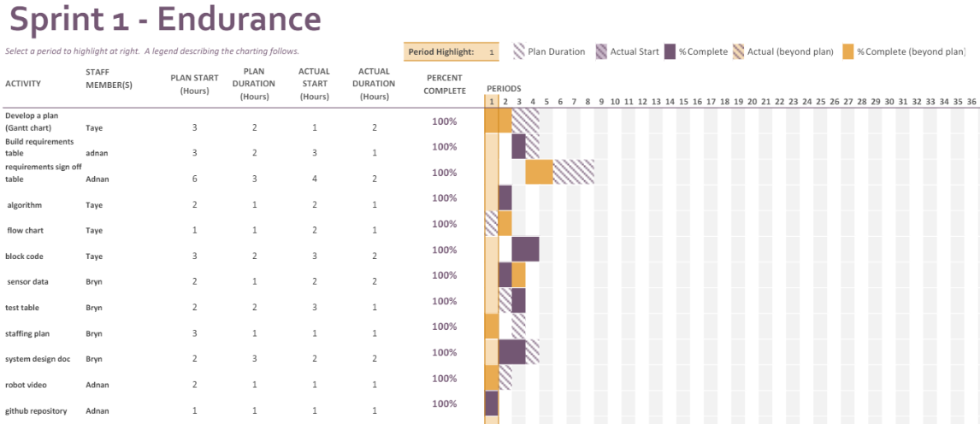

Staffing Plan
Name | Role | Responsibility | Reports To
Bryn | Project Manager | Oversee and plan development/create system design document | N/A
Taye | Developer | Create Gantt chart/algorithm/flow chart | Bryn
Adnan | Developer | Develop block code/upload censor data | Bryn

Sensor Data Program
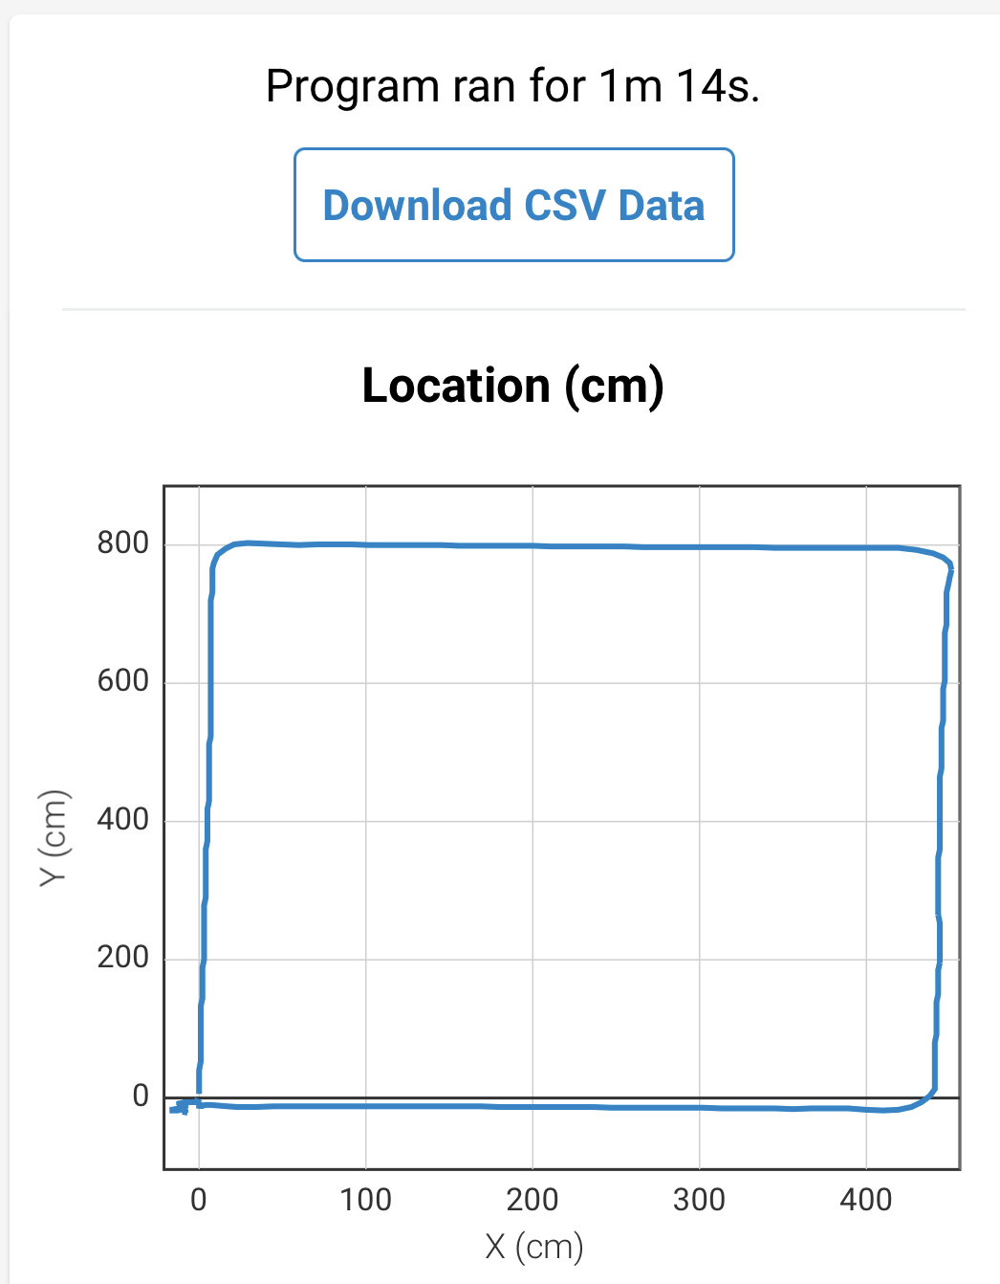

Block Code
